Hydroponica Homes XPRIZE Carbon Capture
Demonstration of a Microfarm – a working part of Forest Farm invention
“Bioagricultura Casa Blanca". Calle 14, Lote 20. Parcelación Casa Blanca. Pachacámac. Lima. Peru
“Don’t blame your poverty. Transform your poverty using affordable technologies and processes to improve your quality of life and happiness”” Ulises Moreno.
“We sow ideas and seeds to harvest what nature and organic farming give us”. Ulises Moreno and Carmen Felipe-Morales
A Forest Farm is a new type of farming which will provide income while sequestering carbon. The model is of a four-hectare piece of land, with one hectare in a micro-farm and three hectares planted into a forest.
What we demonstrate is the micro-farm portion of the Forest Farm. The demonstration is a micro-farm that is now 42 years old.
Bio Agricultura Casa Blanca is a one-hectare micro-farm owned by former University professors Ulises Moreno and Carmen Felipe-Morales.
The farm is on desert land 35 km south of Lima, Peru. The annual rainfall is less than 20 mm a year. The land they purchased relies on a nearby river for eight months of the year and a well for the other four months. The well pump requires electricity.
Agroforestry
The goal was to grow guinea pigs for the local market. Guinea pigs are vegetarian and they decided to grow a legume grass as the primary food for the guinea pig. To produce crops, they established agroforestry in the back 3000 m² of the property. Agroforestry plants rows of trees and grows crops between the rows. The trees they planted was a mixture of 36 species of trees. There are 60 (Pouteria lucuma) trees (from Sapotacea family), native to the Andean valleys of Ecuador, Peru, Bolivia and Chile. The tree fruit, called lucuma, is used in gastronomy to prepare sweets.
The crop they grew between the trees are fast growing legume grasses used to feed 1000 guinea pigs. The guinea pigs are fed this grass and given no water, which is obtained from the grass. This practice follows ancient traditions of raising guinea pigs.
Because the crops are legumes, root nodules of bacterial colonies increase nitrogen in the soil as the crops grow. This supplies some nitrogen to the trees in the agroforest plot.
The United Nations Programme on Reducing Deforestation and Forest Degradation (UN-REDD) recommends agroforestry as a method to reduce deforestation and increase carbon sequestering. The recommendation is to establish agroforestry on degraded lands, or cropland, but not to replace forests with agroforestry.
There are now efforts to establish carbon credits for agroforestry, but the process is difficult because there are so many types of trees and methods of agroforestry.
For Casa Blanca we have estimates of the carbon that has been sequestered in the trees and soils of the agroforestry portion of the micro-farm. There are several methods to estimate carbon in trees including literature data, satellite data, ground truthing and forest modeling.

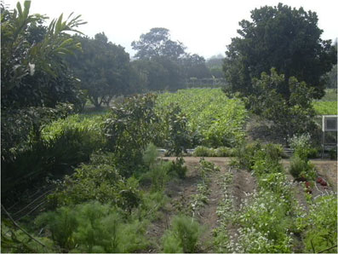
Figure 1. The background shows the agroforestry, rows of trees planted with legume crops for guinea pig food. Foreground is owner’s vegetable food plot.
Agroforest trees and crops
While agroforests are considered a strategy to sequester carbon, there is sparse data on the carbon sequestering potential of agroforestry.
Estimates in literature (Dhyani et. al., 2020) provide a range for agroforestry systems in central India from 0.29–15.21 t/C/ha/yr. Based on literature, 0.3 ha in agroforestry has the potential to store carbon 0.087 to 4.6 t/C/yr.
Agroforest Trees
The agroforest portion of Casa Blanca has 60 Pouteria lucuma trees. The computed biomass for the species Pouteria lucuma (50.39 t/ha) and 2.5.20 t C/ha. The CO2 capture equivalent for Pouteria lucuma is 6.16 tC02/ha (Sandy and Miqueas, 2019). The portion of trees in the agroforestry portion is estimated at 0.05 ha and so the t/CO2/yr of the trees is 0.308 tCO2
Site survey needed
Casa Blanca is an ideal study area to track the increase in soil carbon, and agroforestry. From starting as a desert, the soil carbon accumulation can be measured, and help determine if the practices at Casa Blanca are going to be a measurable help in carbon sequestering. Our 1000 tonne CO2 proposal will help 166 more farmers increase their carbon in soils and trees. A site survey is essential for determining how micro-farms might sequester CO2 instead of emitting. The COVID pandemic has delayed this process. When possible, a site survey will include soil samples, and trees measured and inventoried.
Soil Carbon
Carmen Morales reports that the organic matter in the soil has increased for 0.3 % to 3.0 %. This means that the soil carbon has increased from 0.15 to 1.5% since the farm started. This shows that the soil is a carbon sink, but more soil samples need to be taken to determine a number for the complete farm.
Compost and soil carbon

The compost is thermophilic compost that produces a rich dark humus. Every year 20 tons of thermophilic compost is added back to the soil. The carbon content of the compost is about 20% and the UP EPA calculates the carbon eq of compost is .20 so the carbon sequestering for the compost is 4 t/CO²/yr.
One ton of thermophilic compost will typically contain at least 200-250kg of slow carbon. With good soil management, over 50% of this can be expected to be present in the soil after 25 years, and 5-10% after 100 years (AORA).
The amount of the compost expected to be in the soil in a century is 0.2 t/C yr. This number can be increased to 20% with soil management (AORA) or 0.8 T/C yr.
The amount of soil carbon being sequestered each year, based on soil sample increase and compost added back is from 0.2 t/C a year to 0.8 t/C yr. The soil tests provided by Carmen Morales show the soil carbon increased from 0.15 to 1.5% in the time they have been on the farm. This is calculated as 0.46 t/C per ha per year.

Table 1. Carbon estimates of Casa Blanca and energy inputs and outputs

Metric | Conditions | Carbon | CO2 Sequestered | Other | Basis  Review literature carbon eq
C in agroforesty trees | 60 Pouteria lucuma trees | 0.084 | 0.308 |  | Calculated allometric data
C from soil sample | Soil test Casa Blanca | 0.46 | 1.687 |  | Verified A.D.
Electricity | annual use for water pump |  | -0.226 | 240 kWh | 0.94 carbon eq kwh
Biogas produced | from biodigester |  |  | 1080m3/yr
Biogas burned | from biodigester |  | -0.130 |  | Winnepeg carn eq
Bioeffluent | from biodigester |  |  | 10.2 m3/yr
Carbon sequestered per year |  | 0.544 | 1.639

Guinea pigs supply manure
Casa Blanca produces 36 tons of chala grass a year for the guinea pig feed in the 2500m² of agroforestry crops. This is a sustainable production, maintained for decades.
About three tons of guinea pig manure is gathered each month and used in the biodigester and in compost piles.
Biodigester
Part of the guinea pig waste is used to feed a biodigester. The biodigester is 10m³ in size and produces 3m³ of biogas each day. That is enough for three lights burning for three hours each day and to power a cooker for three hours.
The biodigester also produces an effluent which is called Biol. This is an organic hydroponic nutrient that can be added to a plants’ water supply. Twenty-eight liters of effluent are produced each day, more than is needed for all the crops on the farm, so the owners can sell the excess.

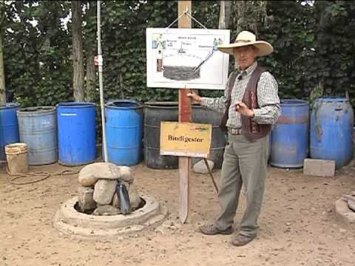
Figure 2. Ulises Moreno showing a class the diagram of the biodigester. The rocks at left and pipe are the outlet to capture 3 m³ of biogas a day. This powers the kitchen, lights and the farm truck.
A biodigester puts biological material in a water slurry, in an oxygen free environment where anaerobic bacteria decompose the material. The biodigester has two outputs, biogas and biodigester effluent.
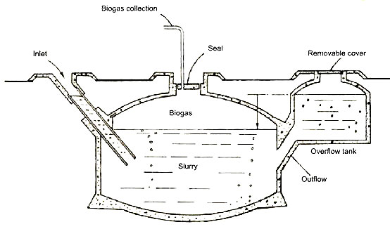
Figure 3. The biodigester has a reservoir of effluent. It produces 200 liters a week of effluent which is a concentrated organic nutrient.
Conclusion
Casa Blanca is a working demonstration of part of our Forest Farms proposal. The micro-farm of one hectare of land shows an integrated approach using animal waste to produce organic nutrient.
The practices at Casa Blanca sequester some carbon, but a site survey is needed to get better estimates. Research and validation at Casa Blanca can help estimate micro-farms possible impact on climate. There are also added benefits such as avoided carbon emissions of commercial agriculture in the US or offering an alternative to swidden agriculture which is partially to blame for deforestation in Peru.
The practices at Casa Blanca are grounded in organic agricultural practices and this enhances soil restoration and preservation for long carbon sequestering in soils. Trees were selected that would live beyond the century. This shows that if agroforestry is going to be part of our mitigation strategy, tree and crop selection will be important.
In our Forest Farm proposal, the larger part of the carbon will be sequestered in the three hectares of forest. The micro-farm provides some carbon storage, and food and income for the family. It also provides three essential inputs for the forest restoration, seedlings, compost and effluent to establish trees in the three hectares of forest.
References
Arthurson, V. 2009. Closing the global energy and nutrient cycles through application of biogas residue to agricultural land – potential benefits and drawbacks. Energies 2:226-242.
Basic Data on Biogas Swedish Gas Technology Centre Ltd (SGC) Scheelegatan 3 SE-212 28 MALMÖ Sweden.

Begg, C, et al., Is biodigester effluent a suitable replacement for commercial fertilizers? Assessing the efficacy of liquid biogas digestate for cultivation of tomato (Solanum lycopersicum) crops in Barbados Journal of Sustainable Tropical Agriculture McGill University, Montreal, Canada University of the West Indies, Cave Hill, Barbados August 23, 2019
Castro-Bedriñana J, and D. Chirinos-Peinado. Nutritional value of some raw materials for guinea pigs (Cavia porcellus) feeding. Transl Anim Sci. 2021 Feb 8.
Dhyani, S.K. A. Ram, R. Newaj, A. K. Handa, and I. Dev, “Agroforestry for carbon sequestration in tropical India,” in Carbon Management in Tropical and Sub-tropical Terrestrial Systems, pp. 313–331, Springer, Singapore, Singapore, 2020
Dhyani, S.K, A. Ram and I. Dev Review Article Potential of agroforestry systems in carbon sequestration in India ICAR–Central Agroforestry Research Institute, Jhansi, Uttar Pradesh 284 003 Received: 1 July 2015.

Fulhage, C.W. Sievers and J. Fischer Generating Methane Gas From Manure Department of Agricultural Engineering Extension University of Missouri.
Grant, B. D. Le Good, and M. Warnken, Using compost to build and maintain soil carbon Australian Organics Recycling Association (AORA).
Hao X, C Chang, F.J. Larney, G. R. Travis, Greenhouse gas emissions during cattle feedlot manure composting, Journal of Envirnomental Quality. 2002 Mar-Apr:30:376-386.
Intergovernmental Panel on Climate Change (2006), Guidelines for National Greenhouse Gas Inventories, Vol. 2 (Energy), Table 2.2, pp. 2.16–2.17.

IDE (2011), Annual Biogas Users Survey 2010, National Domestic Biogas and Manure Programme, Dhaka.

IRENA (2016), Measuring small-scale biogas capacity and production, International Renewable Energy Agency (IRENA), Abu Dhabi
Magar L. K. , G. Kafle, and P. Aryal, "Assessment of Soil Organic Carbon in Tropical Agroforests in the Churiya Range of Makawanpur, Nepal", International Journal of Forestry Research, vol. 2020.
Morris, D.R., and D.J. Lathwell. 2004. Anaerobically digested dairy manure as fertilizer for maize in acid and alkaline soils. Communications in Soil Science and Plant Analysis 35:1757-1771.
Pimental, D, O. Bailey, P. Kim, E. Mullaney, J. Calabrese, L. Walman, and F. Nelson. And X. Yao. Will Limits of the Earth’s Resource Control Human Numbers? College of Agriculture and Life Sciences, Cornell University, Ithica, NY, 1999.
Pimental, D and M Pimental, Food Energy and Society, University Press of Colorado, 1996. Niwot, Colorado.

Somanathan, E. and R. Bluffstone (2015), “Biogas: Clean energy access with low-cost mitigation of Policy Research Working Paper 7349, World Bank, Washington DC.
Tautges, N.E, J. L. Chiartas, A. C. M. Gaudin, A. T. O'Geen, I. Herrera, K. M. Scow. Deep soil inventories reveal that impacts of cover crops and compost on soil carbon sequestration differ in surface and subsurface soils. Global Change Biology, 2019.

University of California - Davis. "Compost key to sequestering carbon in the soil: Study dug deep to uncover which agricultural systems store the most carbon." ScienceDaily. ScienceDaily, 14 August 2019.
US EPA. Composting in Warm Composting overview UP EPA Archive Document May, 2012.
Tello Sanchez Guianella Sandy and Vargas Urbano Miqueas, Determinación de captura de carbono aplicando ecuaciones alométricas en especies forestales de Schinus latifolius, Eucalyptus globulos, Vachellia macracantha y Pouteria lúcuma en la Universidad Peruana Unión, Lima – Perú UNIVERSIDAD PERUANA UNIÓN FACULTAD DE INGENIERÍA Y ARQUITECTURA Escuela Profesional de Ingeniería Ambiental , Lima, Abril del 2019.

