Part of the XPRIZE Carbon Capture entry for Hydroponica Homes
The part being demonstrated a micro-farm, part of the Forest Farms proposal
Engineering for an integrated organic micro-farm
This document offers a design for a micro-farm based on the example of Casa Blanca in Lima, Peru.
Casa Blanca one-hectare organic farm produces guinea pigs, lucuma fruit, produce, compost, biodigester effluent and without the need of fossil fuel.
The land
For a micro-farm to be successful certain criteria need to be met.
The first is an adequate, reliable source of water. This can be a well, an irrigation water channel, or adequate annual rainfall that can be captured in a pond on the property.
The land should at least be a hectare in size. This design is for a one-hectare property, producing 2500 guinea pigs a year, and produce. A portion of the produce is used for personal use and a portion is sold for income.
Degraded lands can be used or desert with low rainfall if a water supply can be established.
Casa Blanca, our demonstrated example, was established on a desert land with only 20 mm rain a year. A primary challenge for Casa Blanca was to obtain adequate water, both supplied from a nearby river and from a 15 m deep well.
Testing
As a potential site is evaluated, soil and water samples need to be tested for two basic things. Both needs to be checked for poisonous contaminants from prior use. Some lands will need to be excluded from micro-farms for this reason. The water will need to be adequate and suitable for growing crops and trees.
Water samples and soil are also used to determine the best nutrient to use for establishing crops. If this was going to be an inorganic fertigation nutrient, the nutrient can be adapted for exact soil and water conditions. For example, if adequate calcium supply is already in the water, it does not have to be added to the hydroponic nutrient.
Evaluation
The potential site test results are then evaluated to see if the site is suitable to be a micro-farm. Several of the evaluations will be on land of people who have signed up to do a micro-farm and micro-forest. When the tests are suitable, they go onto the next step.
Guinea Pig Micro-farm
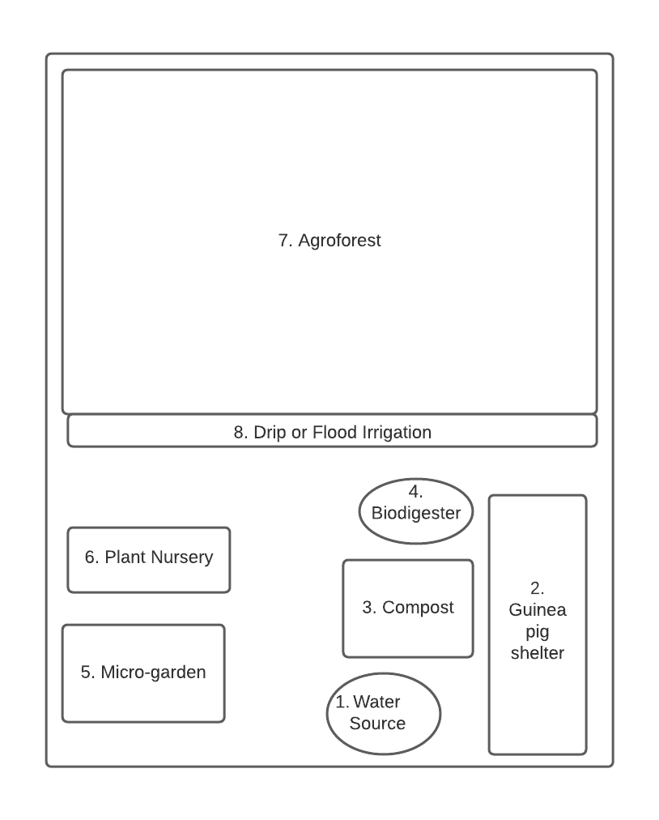
Figure 1. Schematic of the components of a micro-farm.

Table 1. Components of a Guinea pig farm with sizes and estimated costs
Number | Item | Description | Area | Cost | Hand made cost
 |  |  | m2 | US dollars | US Dollars
1 | Water Source | A well, rainwater capture or irrigation canal | 200 | 1500 | 600
2 | Guinea pig shelter | Building or rustic shelter | 100 | 2000 | 1000
3 | Compost | Compost of waste to recycle | 200 | 100 | 40
4 | Biodigester | Dispose of guinea pig waste | 50 | 2500 | 1100
5 | Micro-garden | For daily vegetable diet | 200 | 200 | 100
6 | Plant Nursery | Grow plants for use and sale | 200 | 200 | 40
7 | Agroforest | Trees and crop for animal fodder | 4000 | 100 | 300
8 | Drip irrigation | To reduce water requirements | 100 | 2000 | 1000
 | Totals |  | 5050 | 8600 | 4180

Item 1. Water source
The example Casa Blanca uses 4500m³ of water a year using flood irrigation. While this is a good option for areas of adequate water, this could be reduced by half with drip irrigation. Flood irrigation is traditional and requires less investment.
A micro-farm will need an adequate supply of water to function. In Peru, the disappearance of glaciers should be considered for sites that may depend on glacial water.
Item 2. Guinea pig Shelter
The model of Casa Blanca has a population of 1000 guinea pigs. This number is expected to produce 2500 guinea pigs a year for income and personal consumption.
The shelter at Casa Blanca is a cement block building with a cement floor. The size is estimated at 100 m².
Table 2. Guinea pig food requirements & manure
 | Each | 1000 | 1000
Waste | kg/day | kg/day | year tons
Food required | 0.1 | 100 | 36.5
Waste g | 0.05 | 50 | 18.25
Waste N | 0.00075 | 0.75 | 0.27
Waste P | 0.00035 | 0.35 | 0.13
Waste K | 0.000875 | 0.875 | 0.32

The guinea pigs require 36 tons of chala grass a day. Their waste is estimated at 18 tons while the waste removed from the shelter each year is 36 tons. The waste from the shelter is partly bedding and partly manure. It is divided into compost and feed for a biodigester.
Item 3. Compost
Part of the guinea pig waste, mixed with soiled bedding, is placed in compost piles outside the guinea pig shelter. The 200m² area is on the open ground, in the open air.
Composting is thermophilic with 1.5-meter-high piles layered with alternating layers of guinea pig manure and vegetation. It is stirred from time to time.
Most compost has about 1% nitrogen but in an unavailable form. Nitrogen fixing bacteria are needed to inoculate the legume crop. There are also soil microbes that make phosphorus and potassium more available. An inoculum is recommended for the soil microbes to be added to the compost.
The legume grass grown in the agroforestry field is expected more nutritious than a non-legume grass. The grass samples averaged 0.351% calcium, 0.103% phosphorus, and 0.868% nitrogen, while the legumes averaged 1.373% calcium, 0.180% phosphorus, and 2.283% nitrogen (FAO Daniel, 1934).
Table 3. Expected nutrients in compost and requirements for 36 tons of legume grass.
Item | Compost | Compost | Nutrient in 20 tons compost | Nutrient required per ton legume | Nutrient required for 36 tons legume
 | amount | kg/ton | 20 tons | kg | kg
moisture | 48.80%
Nitrogen (most unavailable) | 1.00% | 10.00 | 200.00 | 22.83 | 1050.18
carbon | 13.10% | 131.00 | 2620.00
Phosphorus (as P2O5 ) 2 | 0.33% | 3.30 | 66.00 | 1.80 | 64.80
Potash (as K2O)2 | 0.44% | 4.40 | 88.00
Calcium (Ca) | 2.12% | 21.20 | 424.00 | 13.73 | 494.28
Magnesium (Mg) | 0.25% | 2.50 | 50.00
Sulfur (S) | 0.11% | 1.10 | 22.00
Sodium (Na) | 393 mg/kg | 0.393 | 7.86
Iron (Fe)
Manganese (Mn) | 234 mg/kg | 0.29 | 5.8

Adding biochar to compost
If we can add biochar to the soil, that carbon should increase soil carbon. The question is if that biochar will increase crop production. There are mixed results in studies, but it is becoming apparent that composted biochar is better than raw biochar.
In studies with quinoa, co-composting biochar resulted in an aboveground biomass yield increase of 305% while applying “raw” biochar resulted in a yield decrease to 60% of the control demonstrating the enhanced benefits of biochar nutrient loading prior to soil application (Kammann 2015).
There are some studies, and ISH bench tests that show biochar can attract and hold positive ions of copper and zinc and therefore cause micro-nutrient deficiencies. To counter this, the biochar could be treated with micronutrients before being added to soil. This could neutralize its negative effect and it could be a source of micro-nutrients in the future. Bench tests are ongoing with ISH and partners. Adding rock phosphate to compost is also being tested.

Item 4. Biodigester

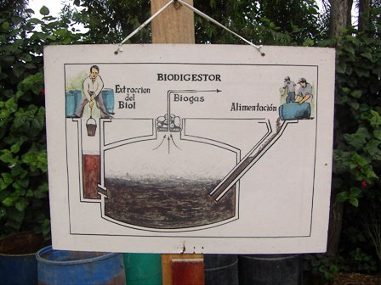
Figure 2. Biodigester illustration at Casa Blanca. This is known as a Chinese style of biodigester. The size of the one is 10m³.
Sizing the biodigester
The biodigester of 10m³ should be able to digest 75 kg of waste a day. The guinea pig manure with bedding should be 150 kg/day. Half will go to the biodigester and half to the compost piles.

Biogas from the biodigester
The 3 m³ of biogas is sufficient to use a biogas cooker for three hours (0.45m3 per hour) and three lamps (0.15m³ per hour). The use of a biogas cooker reduces the need to collect firewood for cooking.
There are significant advantages to changing from fossil fuel or wood burning in terms of CO₂ emissions and other GHG emissions. Firewood emits more N₂O and NH₄ than biogas (IPCC, 2006). There are also benefits in cleaner air indoors when a biogas cooker is used instead of firewood.
Bioeffluent for biodigester
The biodigester produces 29 liters of effluent every day. The process of biodigestion preserves most to the nitrogen in the slurry so the output of the biodigester will reflect the input amount of nitrogen.
Table 4. Comparing inorganic Hydroponic Grow and Bloom Nutrients to Commercial Grow and Bloom nutrients from biodigester effluent.
 | ISH  Hydroponic Grow | Commercial  Biodigester Grow |  |  |  | Biodigester  Biol  Peru
 |  | effluent | dilute 1%
Element | ppm | ppm/liter | ppm |  |  | ppm
Nitrogen | 152 | 39000 | 390 |  |  | 920.00
Phosphorus | 70 | 18000 | 180 |  |  | 92.20
Potassium | 254 | 60000 | 600 |  |  | 295.50
Magnesium | 48 | 20000 | 200 |  |  | 151.20
Calcium | 169 | 5500 | 55 |  |  | 231.00
Sulfur | 115 | 50000 | 500 |  |  | 0.00
Iron | 3.2 | 1500 | 15 |  |  | 0.00
Manganese | 1.95 | 450 | 4.5 |  |  | 0.00
Boron | 1.24 | 150 | 1.5 |  |  | 0.00
Zinc | 0.08 | 130 | 1.3 |  |  | 0.00
Copper | 0.04 | 150 | 1.5 |  |  | 0.00
Molybdenum 0.007 ppm | 0.005
Total ppm | 815 |  | 1949
(The numbers for Biol are from Toribioa, L.K.,2020)
The biodigester effluent is high in nitrogen and low in phosphorus compared to commercial formulations. This reflects the low values of phosphorus in the guinea pig manure. The quality of the biodigester effluent can be improved with a mix of a higher phosphorus input.
Item 5. Micro-garden
The micro-garden has been a poverty solution for UN FAO since 1985 when the first simplified hydroponic gardens were introduced in Jerusalen outside Bogota Colombia. Participants in the project included 130 urban poor families, with 90% of the participants mothers and homemakers. The women earned as much as three times more than their husbands earned in semi-skilled jobs and provided food from the families from overripe or less than perfect crops. They produced 30 types of vegetables in their hydroponic gardens.
A micro-garden of 200 m² should provide about 2000 calories a day of fresh vegetables. The plant nutrient for the micro-garden is worm castings, compost and modified biodigester effluent.

Item 6. Plant Nursery
There will be a need for tree seedlings and saplings for reforestation as Forest Farms become established. The Peruvian government has made it a priority to purchase produce from the rural small farmer, and the potential income from tree seedlings and other nursery plants is substantial.
The plant nursery requires training, seed sources, material for grafting, and adapted plant nutrients to favor root growth. During this transition to forests, there will need to be many more trees than are currently produced in existing nurseries. For example, there are estimates of one trillion seedlings being necessary and the entire production for the US market in 2016 was only 1.6 billion trees. Half of those were used for the timber industries.
The tree nursery is a good investment for both our micro-garden owners and for the micro-farms. The micro-farm will need 120 trees at a minimum and the three hectares of micro-forest will take over 1000. Tree seedlings are also an income of the micro-farm.
Item 7. Agroforest
Agroforestry can reduce soil erosion and double food production. When a legume is planted, in either the trees or the crops, the nitrogen is partially supplied by the soil microbes in the root nodules.
The agroforest has rows of trees planted with a distance apart for crops. In this 4000 m² of the property, the crops are the necessary crop for animal survival. The crop portion of the land is estimated at 3000 m³ of the 4000 m² space. In this space, the legume grass crop for the guinea pigs is raised.
This space is designed to produce 36 tons of crop a year. This amounts to an expected product of 10 kg/m² year. The crops are in constant production with the area where the grass has been harvested composted and then grass replanted. One hundred kilograms of grass is harvested each day.
Tree Species
The trees in the agroforest will be a significant carbon sink for the next 100 years. This can be accomplished with trees that live 100 years, or it can be done with trees that are replaced as they are rotated out, especially if the wood is retained in long lived products and the slash is made into biochar, composted and enhanced with micro-nutrients.
In agroforestry, the 120 trees planted should be a mixed species of trees. The careful choice of trees will add to the income of the farm and continue to sequester caron as they grow.
Item 8. Drip Irrigation

Casa Blanca uses 4500m³ of water each year, using flood irrigation. There is likely to be a shortage of water for agriculture in the future. The glaciers in Peru are retreating and may be gone in 30 years. These glaciers supply 30% of Peru’s water. The possibility of switching from flood irrigation to drip could reduce the amount of water need for the crops by at least 50%. Drip irrigation has 95% water efficiency while flood is only 30% efficient.

In Israel, 95% of the crops are using drip irrigation, including cotton, maize, fruit trees and vegetables. However, the drip system is expensive and will decay over time so it may not be a viable option at present.

Carbon Sequestration
The agroforestry portion of the micro-farm is where most of the trees are planted. The combination of chala grass and lucuma trees are crops that are traditional to Peru. The range of possible carbon sequestered by the agroforestry is taken from literature range of from 0.29–15.21 T/C/ha/yr (Dyhani 2020) and our agroforestry space is 0.4 ha so the range of carbon stored in agroforestry is from 0.116 to 6.08 T/C/yr.

The 20 tons of compost used on the soils has a carbon eq of 0.20, but that does not account for how much of the soil carbon will be in the earth in a century. The initial carbon placed back in the soils is 20% of the 20 tons, so 4 tons. The expected part of that remaining after 100 years in for 5 to 20%, so 0.2 to 0.8 T/C/yr.

If biochar is composted in the compost, a percentage can be included. If biochar is added to the compost at a rate of 10%, 2 tons will be added to the 20 tons of compost. Using the Climate Trust estimate of 80% left in 100 year the sequestered carbon from the biochar is 1.6 T/C/yr.

Table 5. Carbon Estimates for a micro-farm with agroforestry

Item | Carbon sequestered |  | CO2 sequestered |  | Other output/input
 | min | max | min | max
 | T/C/yr | T/C/yr | T/CO2/yr | T/CO2/yr
Agroforestry Trees & Soils | 0.116 | 6.08 | 0.43 | 22.3
Increase in soil carbon compost remain 100 yr | 0.2 | 0.8 | 0.73 | 2.93
Increase in soil carbon with biochar compost 80% in 100 yr |  | 1.6 |  | 5.86
Biogas produced |  |  |  |  | 1080 m3/yr
Effluent |  |  |  |  | 10.5m3/yr

Micro-farm as an alternative for slash and burn agriculture.

Shifting or slash and burn agriculture clears native vegetation, then plants a crop for a few years until the soil is depleted, and then moves on and clears another piece of land.

Shifting agriculture is hard work and produces very little corn. In 1996, David Pimental estimated the inputs and outputs of swidden agriculture to produce corn in Guatemala. From 1415 hour of labor only about 1 ton of corn was produced in a hectare. There is also 3 tons of corn stalk for fodder.

The Casa Blanca model of a micro-farm is an alternative for farmers practicing shifting agriculture. It should produce more income with less effort. The option of agroforestry using compost and effluent is a reduction in human labor required, and increased productivity. There is no need to clear a new section of land if the micro-farm is owned and is in regular production.

The example of Casa Blanca has maintained soil fertility in the cropland section for 40 years and the practices show that if soil nutrition practices are flowed it will continue to do so.

Micro-farms in climate change
In the past decade, torrential rains have caused floods in Peru that have wiped out crops for thousands of rural farmers. The floods of March 2021 were some of the worst in memory. They perhaps are a warning for the future, of rainstorms that overwhelm the natural pathways of water. The sites chosen for micro-farms should consider the possibility of flooding.
The suggested amount of water required for the Casa Blanca model may not be available in the future Peru. While there are areas with adequate rainfall, if placing a micro-farm in a desert area, as Casa Blanca is, the entire system is dependent upon the water source. Currently there is a nearby river, that has water eight months of the year and a well that is adequate in the remaining months. But the future might have water restrictions that threatened current practices.
Micro-farms in Peru
The United Nations Collaborative Program on Reducing Emissions from Deforestation and Forest Degradation in Developing Countries (UN-REDD) partners with developing countries to support activities to end the 11% deforestation contribution to CO² emissions.
Peru has developed its plan which is online at Peru’s National Strategy on Forests and Climate Change (ENBCC). The next phase of the agreement is to test practices that will help reduce deforestation. Casa Blanca represents a successful practice that can be used as a possible strategy to change current practices.

Forest Farms
The Institute of Simplified Hydroponics proposes expanding the micro-farm from one to four hectares and planting three of those hectares into forest. This provides the inputs and the labor to reforest degraded lands. The micro-farm supplies the compost, the plant nutrient and the seedlings needed for the reforestation.
People paying a carbon tax may rather support a poor farmer in Peru gain economic security than pay for putting carbon in a deep hole in the ground.
References

Borrero, C., 2001, Abonos Organicos. http://www.infoagro.com/abonos/abonos_organicos_guaviare.htm
FAO, 2011, Manual de biogas. http://www.fao.org/3/as400s/as400s.pdf
FAO. Daniel, H.A., calcium, phosphorus, and nitrogen content of grasses and legumes and the relation of these elements in the plant [1934] Journal of the American Society of Agronomy
ISSN : 0002-1962

Hellal, F.A.A., F. Nagumo, and R. M. Zewainy, Influence of phosphocompost application on phosphorus availability and uptake by maize grown in red soil of Ishigaki Island, Japan, Agricultural Sciences Vol. 4 No. 2 (2013).

Intergovernmental Panel on Climate Change (2006), Guidelines for National Greenhouse Gas Inventories, Vol. 2 (Energy), Table 2.2, pp. 2.16–2.17.
Kammann, Claudia I., H.P. Schmidt, N. Messerschmidt, S. Linsel, D. Steffens, C. Muller, H. Werner Koyro, P. Conte, and S. Joseph, et al. “Plant Growth Improvement Mediated by Nitrate Capture in Co-Composted Biochar.” Scientific Reports, vol. 5, no. 1, 2015, doi:10.1038/srep11080.

Lehmann, S. A., M. Kleber, G. Pan, P. Singh, S.P. Sohi, A.R. Zimmerman, Persistence of biochar in soil Biochar for Environmental Management, Routldge, 2015.

Meneses Quelal, W.O., Velázquez-Martí, B., Gaibor Chávez, J. et al. Evaluation of methane production from the anaerobic co-digestion of manure of guinea pig with lignocellulosic Andean residues. Environ Sci Pollut Res 29, 2227–2243 (2022).
Meneses Quelal, B. Velázquez-Martí, J. Gaibor Chávez , and Z. Niño Ruiz , Andrés Ferrer Gisbert, Evaluation of methane production from the anaerobic co-digestion of manure of guinea pig with lignocellulosic Andeans residues Orlando Washinton, August 2021.
Pimental, D and M Pimental, Food Energy and Society, University Press of Colorado, 1996. Niwot, Colorado.
Saxena A. K., M. Kumar, H. Chakdar, N. Anuroopa and D.J. Bagyaraj, Bacillus species in soil as a natural resource for plant health and nutrition. Journal of Applied Microbiology ISSN 1364-507 October 2019.

Sergio S. Espejo Huerta, Jheidy M. Siesquen Crisanto, Carlos A. Castañeda Olivera, Elmer G. Benites Alfaro Biofertilizer of Guinea Pig Manure for the Recovery of a Degraded Loam Soil Universidad César Vallejo, Campus Los Olivos, Lima, Peru, Chemical Engineering Transactions Vol. 86, 2021.

Toribioa, L. K., G. O. Castroa, J. W. Valverde, A. B. Flores, C. A. Olivera, E. G.B. Alfaroa Calorific Value of Biogas Obtained by Cavia porcellus Biomass Chemical Engineering Transactions, Vol. 80, 2020.

Zomer R. J., H. Neufeldt, J. Xu, A. Ahrends, D. Bossio, A. Trabucco, M. van Noordwijk and M. Wang, Global Tree cover and biomass carbon on Agricultural land: The contribution of agroforestry to global and national carbon budgets. Scientific Reports 6, Article number: 29987 (2016). doi:10.1038/srep29987.

